**MINI PROJECT – II**

**(2018-19)**

**BLIND VOICE MAIL**

# 

**SYNOPSIS**



**Institute of Engineering & Technology**

**Team Members**

Shalabh Kumar (161500498)

(https://github.com/mittalshalabh16/Mini-Project-2)

Alisha Raj (161500057)

## Supervised By:

Divyansh Bhardwaj

**Asst. Professor**

**Training Department of Computer Engineering & Applications**

**Problem Statement**

In today’s digital world, most of the works are dependent on internet such as official works are specially done through mails. But there are some other people also who are incapable of using these facilities and some of these incapable people there is also a lot of no. of Blind people. They cannot use smartphones new technology and even can’t use emails which is a basic thing as they can’t see the keyboards and keypads.

**Reason**

One of the main fields that Internet has revolutionized is communication. And talking about communication over Internet, the first thing that comes in our mind is E-mail. E-mails are considered to be the most reliable way of communication over Internet, for sending or receiving some important information. But there is a special criteria for humans to access the Internet and the criteria is you must be able to see. You must be thinking that what sort of criteria is this, everyone with eyes can see. But there are also especially abled people in our society who are not gifted with what you have. Yes there are some visually challenged people or blind people who cannot see things and thus cannot see the computer screen or keyboard.

So, for the betterment of society and giving an equal status to such especially abled people we have come up with this project idea which provides the user with ability to send mails using voice commands without the need of keyboard or any other visual things.

**Objective**

The main idea of this project is to recognize text character and convert it into speech. Existing systems for text recognition are typically limited either by explicitly relying on specific shapes or colour masks or by requiring user assistants or may be of high cost. The following are the objectives of the projects:

1. To provide facilities of communication for visually impaired persons.

2. To provide voice based mailing service where they could read and send mail on their own.

3. To provide low cost system that will be able to automatically locate and read the text allowed to visually impaired persons.

4. To design and analyse the pre-processing modules for text recognition.

5. To design and analyse the segmentation process for extracting and resizing letters.

**Literature Survey / Feasibility Study**

A survey shows that there are more than 250 million visually challenged people around the globe. That is, around 250 million people are unaware of how to use Internet or E-mail. The only way by which a visually impaired person can send an E-mail is, they have to dictate the entire content of the mail to a third person (not visually challenged) and then the third person will compose the mail and send on the behalf of the visually impaired person.

**Future Scope**

For people who can see, e-mailing is not a big deal, but for people who are not blessed with gift of vision it postures a key concern because of its intersection with many vocational responsibilities. This voice based email system has great application as it is used by blind people as they can understand where they are. E.g. whenever cursor moves to any icon on the website say Register it will sound like “Register Button”. There are many screen readers available. But people had to remember mouse clicks. Rather, this project will reduce this problem as mouse pointer would read out where he/she lies. This system focuses more on user friendliness of all types of persons including regular persons, visually compromised people as well as illiterate.

**Methodology**

The following are the three methods in the proposed work:

Speech to Text Conversion: Speech to text conversion is the process of converting spoken word into written text. A speech to text system can also improve system accessibility by providing data entry option for visually impaired person. This process is also often called speech recognition. The term voice recognition should be avoided as it is often associated with the process of identifying person from their voice i.e. speaker recognition.

Text to Voice Conversion: It will also similar to the voice to text conversion but in reverse order. Which also based on HMM (Hidden Markov Model) algorithm.

Voice recognition: Speech recognition for application Voice SMS is done on Google server using the HMM algorithm. The HMM algorithm is briefly described in this part process involves the conversion of acoustic speech into a set of words and is performed by software component.

**System Requirements**

***Software Requirements:***

1. Front End: JSP, Java

2. Back End: SQL

***Hardware Requirements:***

1. Pentium Core processor

2. 512 MB RAM

3. Microphone

**Testing technologies**

UI design: In this phase the UI or the user interface of the project is developed. That is, the designing of the web pages which the user will use to interact.

**Database design:** The database is considered to be the main pillars of every project. In our application, database is used to store user details such as name, age etc. Database here is also used to keep information about the emails sent or received or in draft. The complete proposed design of the database is shown in the ER-diagram below. This ER-diagram shows all the tables with all fields and also relationship between different tables.

System design: In this phase a complete flow diagram of the working system is designed. This flow diagram will show the details of all the events like actions to be performed for an event.

***Implementation***

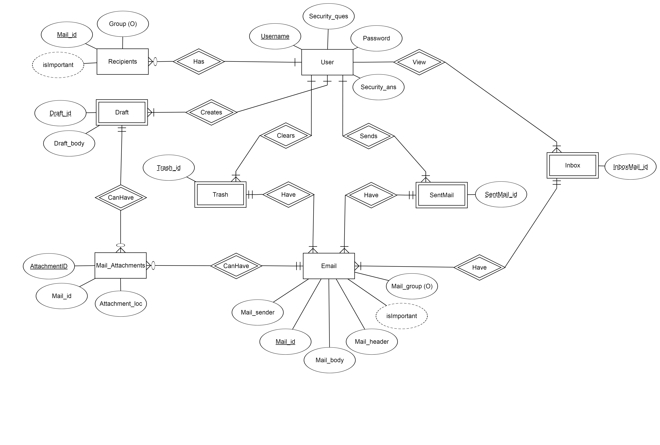

**What contribution would the project make and where?**

This project is proposed for the betterment of society. This project aims to help the visually impaired people to be a part of growing digital India by using internet and also aims to make life of such people quite easy. Also, the success of this project will also encourage developers to build something more useful for visually impaired or illiterate people, who also deserves an equal standard in society.

**Scope for extension**

Voice could be extended to image attachments and other options such as indentation, fonts etc., that are available with normal E-Mail.

**Conclusion**

Voice based architecture helps blind people to access e-mail with no difficulty. The proposed system entirely focuses on the benefit of the blind in making use of advanced technology for their growth and improvement. It also helps handicapped and illiterate people. This project will be very much useful fortoday‟s generation either blind or physically challenged to move a step forward in their way in an easy manner to achieve their desire.